INTRODUCTION TO MLS
Define ASI and MLS
ASI: Automated Sourcing Intelligence is the name of the solution being offered, and expands possibilities to do more with MLS. It is powered by the MLS algorithm.
MLS: Multi-Level Search is an algorithm that searches through multiple levels of product structure for supplies or ways to build supplies.
Product structure is considered as a network of parts linked together through Bill Of Materials (BOM), transfer, and substitution relationships.
When multiple ways to satisfy a driver demand exist, such as multiple PartSources, MLS analyzes the choices and relies on a predetermined list of ranked objectives to decide which decision is better. MLS also makes part sourcing decisions using BOM alternates.
There are 11 objectives, but the three highest ranked are:
- On time availability
- Part source priority
- New purchase cost
The MLS algorithm's selection process
This simplified selection process describes the steps that the MLS algorithm takes when deciding on a part source selection to fulfill demand.
- Step 1
Sort demands
Sort demands by priority and date.
Note: Priority is not applicable when Expiry logic is used.
- Step 2
Begin with the first demand
Begin with the first demand.
- Step 3
Generate a trial
  - If there are enough existing on-time supplies, stop.
  - Create a trial planned order for the needed supply using all eligible part sources.
  - Confirm the planned order of the best part source based on MLS ranked objectives at the end of the trial.
    - If all trial planned orders are late, confirm any less-late existing supplies instead.
- Step 4
Evaluate the confirmed option
Evaluate the confirmed option and determine if there is enough supply to satisfy the demand on time:
  - If yes, stop.
  - Otherwise, repeat the Generate a trial step.

Differences between MLS and non-MLS
What are some of the differences between MLS and non-MLS in terms of demand processing sequence?

Non-MLS or the breadth-first approach to demand processing
- By default, netting or Material Requirements Planning (MRP) logic happens top down, level by level.

- All demands on the same level are processed first, creating PlannedOrders (CPO) where necessary, before moving down to the next level.
- This processing sequence ensures that component level always has the complete demand picture (input demands + dependent demands) before netting begins for that level.

MLS or depth-first approach to demand processing
- When MLS is enabled, demands are processed in a depth-first approach.
- At a high level, the demand processing sequence processes the driver demand and all its dependent demands (from top to bottom) across all levels first before moving on to the next driver demand.

- In more detail, all input demands from across all levels are collected up-front, sorted in a certain way, and processed one by one.
- As each demand is processed, a temporary PO is created (assuming there are no OnHand or ScheduledReceipt on the driver level), explode through BOM/transfer links, and seek supply on the component level.
- This continues until the bottom level is reached, and assuming that this is the chosen path, all supplies used to satisfy the driver demand get created at the same time.

MLS prerequisites
- There are three main core algorithms that you should be aware of before using MLS. These algorithms happen in sequence when fulfilling demands.
Three Algorithms
1.Netting
2.CTP
3.FLP

Netting (Net Material Requirements Planning) calculates what supplies are needed and when.
DueDates are calculated in netting (or given as input).
- Netting calculations happen top-down in product structure
- Determines effective demand
- Reschedules existing supply
- Creates new planned orders
- Explodes supplies through BOM

CTP (Capable-to-Promise) calculates when you are actually going to get your supplies. The CTP algorithm is dependent on the results generated by the Netting algorithm and is used to determine material shortages, allotment of materials and the dates when supplies and demands are available. AvailableDates are calculated in CTP.
- CTP calculations happen bottom-up
- Occurs after Netting completes
- Determines supply available dates
- Allocates supplies to demand
The following resources are used for CTP calculations:
Workbook | Worksheet | Calculated Table
Planning Sheet | Supply & Demand | CTPActivity
Constraint Manager |  | ConstraintUsed  ConstraintLoad  ConstraintSpreadLoad

FLP (Full Level Pegging) calculates which components across all levels that went into satisfying this demand. The FLP algorithm is dependent on the output produced by the CTP algorithm and ties together single-level allotments (found in the calculated SupplyDemand table) and use them to generate various allotment details in consideration of the product structure as a whole.
- FLP calculations happen top-down
- Occurs after CTP completes
- Ties together SupplyDemand allocations made throughout the product structure
- Useful for showing how component supplies are consumed at higher levels

The following resources are used for FLP calculations:
Workbook | Worksheet | Calculated Table
Planning Sheet | Supply Analysis | WhereConsumedForSupply
Supply Order Analysis |  | WhereConsumedForSupply
PlanningSheet | Pegged Supply Allocation | WhereConsumed
Demand Order Analysis |  | WhereConsumedForDemand  WhereConsumedForForecast

Netting family
What is a family?
Family is a term that is often mentioned when working with advanced algorithms such as constraint scheduling, global substitution, BOM substitution, and Multi Level Search.
A family is a group of parts that are collected into the same calculation entity before a core algorithm is run. Parts that need to be considered together before netting, form a netting family. Parts that need to be considered together before CTP, form a CTP family. There is no family for FLP.
Family size is the total number of parts inside a specific family.
The focus here will be on Netting family since the majority of performance issues related to algorithms come from netting.
Impact of family on overall complexity and performance
For processing the same set of driver demands, advanced algorithms will naturally take more time as more complex logic is executed. In addition, the way multi-threading (calculating results for multiple parts at the same time) works with netting families also affects performance.
By default, the RapidResponse query engine has multi-threading enabled, which means that the data server will try to calculate things that can be done in parallel. Since each netting family is considered as a separate calculation entity, the calculation inside each family is single-threaded. The bigger family size gets, the less multi-threading opportunity there is for the RapidResponse query engine to work with.
Examples
Non-MLS example
Note: Click the graphic to see more detail.

In this example, MLS is disabled.
- Since there are no advanced analytics active, there is no netting family formed (no netting family size greater than 1).
- US and CA sites each have lots of IDs. Netting for Bike at US and Bike at CA can be done in parallel, since they are not inside the same family and have no parent-child dependencies among them.
- After US and CA sites are done, netting for Mfg site gets calculated. The netting performance will be very good.
Note: Click the graphic to see more detail.
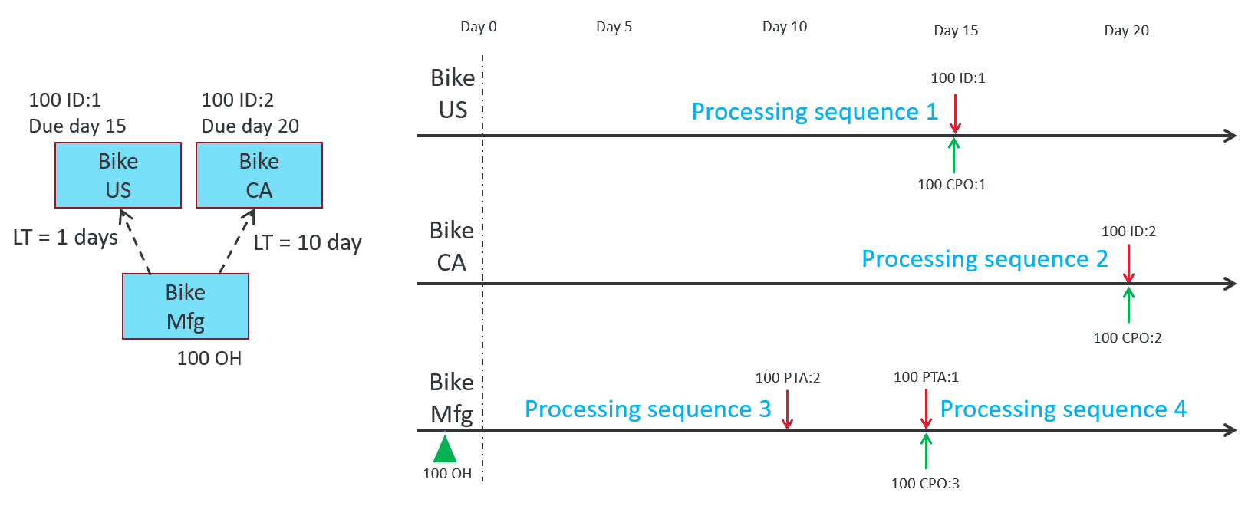
MLS EXAMPLE
In this example, MLS is enabled for all 3 parts.
- This places all 3 parts in the same netting family.
- IDs from US and CA are collected together, and the netting calculation is performed for this family in a single thread.
- The netting performance will be slower than non-MLS because more complex logic is performed by MLS compared to regular netting, and everything is run in a single thread.
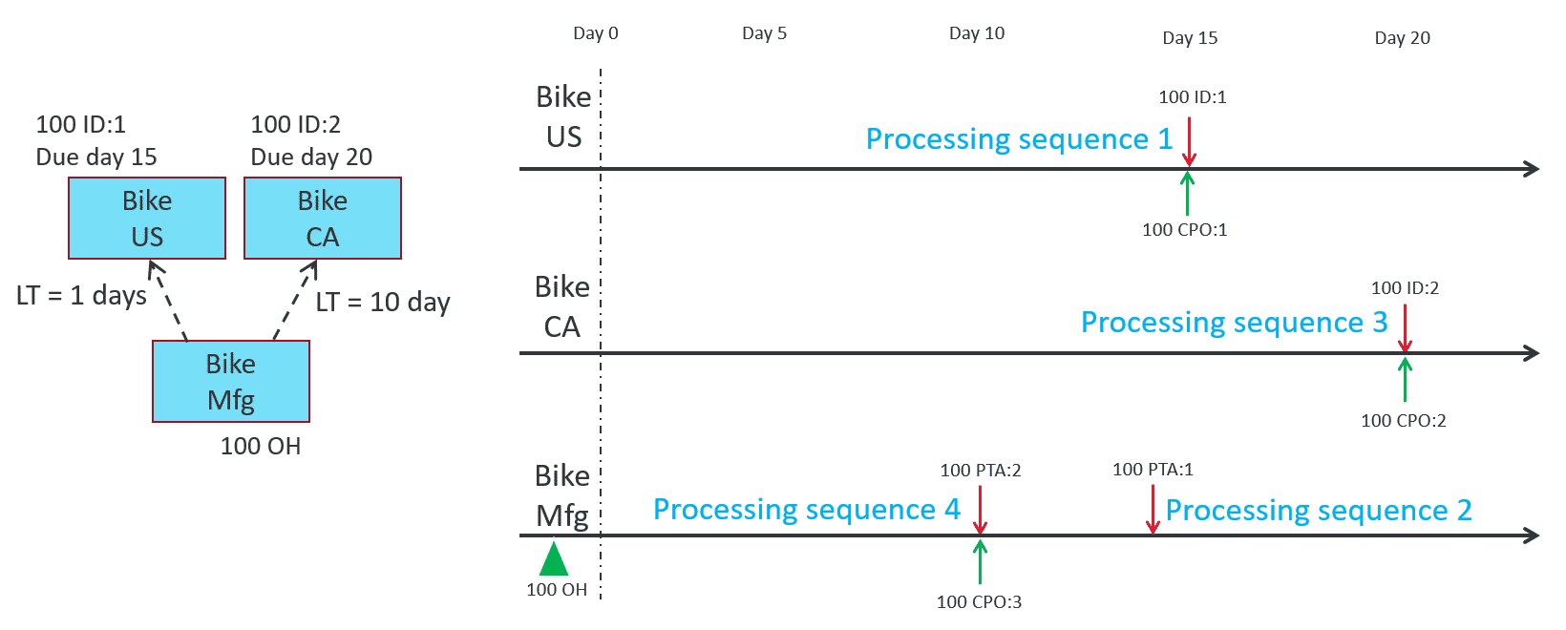
Key concepts
- Netting calculation is single-threaded inside a netting family.
- Small family sizes make it easy for the RapidResponse query engine to do multi-threaded query execution.
- The sizes of your largest netting families dominate what netting performance you will get. It is recommended to monitor netting family sizes throughout your deployment

RANKED OBJECTIVES
Why choose one path over another?
When there is insufficient on hand inventory or scheduled supply available to meet demand, which requires planned orders to be generated, RapidResponse chooses a part source to supply those orders.
When making part source selection decisions for parts that have Multi-Level Search (MLS) logic enabled, RapidResponse considers part source effectivity, planning time fence, and constraint associated with the assembly part being sourced as well as the part’s sourcing rules.
When using the MLS algorithm, every driver demand tries to go down the best path based on information seen at the time of processing.
Multi-level part source selection criteria, otherwise known as ranked objectives, help guide MLS on which path is the best path to take. As we compare each objective from top to bottom, the first condition that's different between the paths is the determining condition for which path is taken.
Multi-level part source selection criteria (or ranked objectives)
Multi-level part source selection criteria, also known as ranked objectives, help MLS decide what part source is used to supply demand. If a part has multiple sources to fill demand, and that part has MLS enabled, MLS will go down a list of ranked objectives and compare the part sources to decide on the best source to fill the demand.
Note: In order for a certain objective to take effect, all the objectives before that have to be the same.
List of ranked objectives
MLS will go down this list of ranked objectives one by one in this order, and compare the part sources to determine if one source has an advantage over the other.
1.On-time order availability (or least late)
The main objective and likely the most important one is to determine what part source can satisfy the requirement on time, or least late.
When selecting a part source to supply a planned order, RapidResponse prefers those sources which, considering all component availability, can create the planned order on time. All sources that can create the planned order on time are considered equal in this criteria. (No special consideration is given to sources which can supply the order early.)

If no part source can provide planned orders on time to satisfy a given requirement, then RapidResponse prefers those sources which can satisfy the requirement the least number of days late (least late).

If multiple part sources can satisfy a requirement on time (or least late), then MLS moves on to the next ranked objective which is then used to choose among those sources.

2. Part source priority
Preference is given to higher effective priority sources over sources with lower effective priority.
If multiple part sources are eligible to satisfy a requirement on time (or least late), then RapidResponse prefers part sources with higher effective priorities to those with lower effective priorities.
That is, it will source as much as it can from a higher priority source before considering lower priority sources.

Note: Priority is determined from PartSource.Priority. By default, lower values in this field equate to higher effective priorities, but this is configurable based on the SourceRule.PriorityRule setting.
If there are multiple part sources of a given priority eligible to provide a supply, then MLS moves on to the next ranked objective which is then used to choose among those sources.

3. New purchase cost
Preference is given to part sources with lower material purchase cost.
If all prior criteria have been evaluated and multiple sources are still considered equal, the source with the lowest material purchase cost is chosen. This part of the selection criteria is meant to help avoid selecting sources that have relatively lower yields and hence higher purchased component costs in their path.
To determine the cost associated with a new planned order for a purchased part, the order quantity PlannedOrder.Quantity is multiplied by the part source's material cost value PartSource.MaterialCost.
To determine the cost associated with a new planned order for a make or transfer part, the new purchase costs from its dependent demands are rolled up and summed together. It is the sum of material costs from new purchase orders generated to satisfy the driving requirement.

- Existing supply cost
Preference is given to part sources with lower rolled up cost from existing supply.

If all prior criteria have been evaluated and multiple sources are still considered equal, the source with the lowest rolled up cost from existing supply is chosen.

For purchased parts, the determination of existing supply cost depends on the type of supply as follows:
Scheduled receipts - the quantity of the receipt used for the requirement is multiplied by PartSource.MaterialCost.
Planned orders (existing) - the quantity of the previously created order that is used for the requirement is multiplied by PartSource.MaterialCost.
On-hand inventory - the quantity of inventory used for the requirement is multiplied by OnHand.UnitCost (as long as the UnitCost is positive).
Otherwise, the quantity is multiplied by the MaterialCost defined on the effective PartSource record as determined from the dependent demand's due date.
Co-products - the quantity of co-product supply used for the requirement is multiplied by the MaterialCost defined on the first effective PartSource record as determined from the dependent demand's due date.
For make and transfer parts, existing supply cost is based on rolled up existing supply costs from its dependent demands. It is the sum of purchase costs from existing supply portions used to satisfy the driving requirement.
Note: This optional criteria applies only if MultiLevelSearchRule.NewPurchasesCost is set to Use.
Otherwise, (if MultiLevelSearchRule.NewPurchasesCost is set to Ignore), then the cost of existing supply is not considered.
If there are multiple part sources available with the same existing purchase cost, then MLS moves on to the next ranked objective which is then used to choose among those sources.

- Component supply level (input supply only)
Preference is given to part sources that can provide supply from a higher level (lower depth) in the product structure.

If multiple part sources of a given priority level are eligible to satisfy a requirement, and the lowest level supply being supplied comes fully from input supply, then preference is given to the source that can provide that input supply from a higher level in the product structure.

This criteria is intended to potentially reduce the number of new orders that are required to assemble lower level components throughout the structure.

If there are multiple part sources available with the same component supply level, then MLS moves on to the next ranked objective which is then used to choose among those sources.

6. Component supply type (bottom level component)
Preference is given to part sources with a preferred component supply type (in this order On Hand inventory, Scheduled Supply, and Planned Orders) at the lowest component level.
If all prior criteria have been evaluated and multiple part sources are still considered equal, then the lowest level of component supply used in each source’s path is compared.
Preference is then given to sources based on the supply type used at that bottom level along with the MultiLevelSearchRule.ScheduledSupplyRule setting as follows:
If ScheduledSupplyRule is set to PreferOnHand (default setting), then component supply is preferred in this order:
- On Hand Inventory
- Scheduled Supply (scheduled receipts, inventory transfers, supply allocations, and/or co-products)
- Planned Orders
Otherwise, if ScheduledSupplyRule is set to EqualToOnHand, then component supply is preferred in this order:
- On Hand Inventory or Scheduled Supply (scheduled receipts, inventory transfers, supply allocations, and/or co-products).
- Planned orders
Note: This part of the selection criteria is intended to try to use up on hand and scheduled component supply before creating new planned orders.
If a mix of component supply types is used at the bottom component level under a source, then that level is assumed to be the least preferred of those supply types.
In other words, “On Hand Inventory” means all component supply at the bottom level must be from on hand, “Scheduled Supply” means all component supply at the bottom level must be from either scheduled supply or a mix of scheduled supply and on hand, and “Planned Orders” means any or all supply at the bottom level is from planned orders.
If there are multiple part sources available with the same component supply type, then MLS moves on to the next ranked objective which is then used to choose among those sources.

7. Scheduled receipts (substitution and pooling)
This objective only applies when using MLS together with global part substitution or inventory pooling.
Preference is given to part sources that can use scheduled receipts at any level within the product structure, rather than creating a new planned order.
If all prior criteria have been evaluated and multiple part sources are still considered equal, then sources that can use scheduled receipts at any component level (including unallocated scheduled receipts) are preferred over sources requiring new planned orders. This might help fully allocate or use up existing scheduled receipts before planning new supplies. This criteria only applies when using MLS with either global part substitution or inventory pooling logic as follows:
- When using global part substitution, if PartType.SubstitutionPreference is set to ScheduledSupply, a source that can use component supply from a scheduled receipt, even if is unallocated, is then preferred over one that requires a new planned order.
- Similarly when using inventory pooling logic with MUEPoolNettingType.PoolRule set to Net, if multiple sources can satisfy a demand equally well and are considered equal in priority and depth/level, then a source that can utilize an unallocated scheduled receipt in one pool is preferred over a source that requires a new planned order to be created in another pool.
Note: This criteria supports better and more consistent use of scheduled receipts when using MLS with global part substitution and/or inventory pooling logic.
If there are multiple part sources available with the same amount of scheduled receipts or no scheduled receipts, then MLS moves on to the next ranked objective which is then used to choose among those sources.

8. Planned expiry date (material expiry)
Preference is given to part sources that can provide supply with an earlier planned expiry date.
When Expiry planning logic is used and multiple sources are otherwise equal, the date that supply from each source is planned to expire (including consideration for expiration of its components) is then evaluated.
Sources that can provide supply with an earlier planned expiry date are then preferred. This is intended to help make sourcing decisions that minimize supply risk and reduce the total amount of component material that will ultimately expire.

Note: Although MLS logic can help to make better sourcing and substitution decisions on parts subject to material expiration (such as, by using up existing and earlier expiring supply), some limitations do exist when using MLS and material expiry logic together.
These limitations are further discussed in Lesson 4, MLS and Expiry planning.
If there are multiple part sources available with the same planned expiry date, then MLS moves on to the next ranked objective which is then used to choose among those sources.

9. MLSPreTargetSequence
This objective indicates a user defined preference in part sources. Preference is given to a lower value.
If all prior criteria have been evaluated and multiple sources are still considered equal, then the record with the lowest PartSource.MLSPreTargetSequence value is used to supply the requirement.
The MLSPreTargetSequence field acts as an additional selection criteria indicating a preference between part sources of a given priority. For example, this field might be used to specify a preference between secondary part sources.
If there are multiple part sources available with the same MLSPreTargetSequence value, then MLS moves on to the next ranked objective or subsequent criteria, which is then used to choose between those sources.

10. Part source target
This value is used to determine the percentage split of planned requirements among the active part sources.
If all prior criteria have been evaluated, and multiple part sources are still considered equal, then this value (as set on the PartSource.Target field) is used to determine the percentage split of planned requirements among the active part sources.
Depending on the setting in the SourceRule.AllotmentRule field, this split among sources is either made proportionally between sources for each requirement or on ongoing basis with each requirement meant to be satisfied by only one source whenever possible.
If all active part sources have their Target set to 0, this indicates demands should be evenly split across the eligible sources.
The part’s SourceRule.AllotmentRule setting is used to determine how those Target values are used when sourcing a requirement from multiple potential sources:
- Ongoing - the outstanding requirement is fully allotted to the part source with the highest calculated Target quantity.
- Proportional - the outstanding requirement is first allotted to the part source that has the highest remaining Target quantity up to the point where is Target is reached. Sourcing then shifts to the part source with the next highest remaining Target quantity remaining until the requirement is fully sourced.
Note: AllotmentRule settings of “OngoingToDate” and “ProportionalLotSize” are not supported with MLS logic. If these settings are used with parts enabled for MLS logic, the “Ongoing” and “Proportional” settings are applied instead.
If multiple part sources are still being considered and have the same part source target value, then MLS moves on to the next ranked objective which is then used to choose among those sources.

11. Secondary priority
A final criteria for prioritizing sourcing. Preference is given to a lower value which equates to a higher effective priority.
In cases where, after applying targets, multiple sources are still considered equal for supplying a requirement, the PartSource.SecondaryPriority field is used to choose the source.
By default, lower values in the SecondaryPriority field equate to higher effective priorities (but this is configurable based on the SourceRule.PriorityRule setting).

In making the best decision for part source selection, the MLS algorithm goes down this list of objectives and compares them for each part source.
For example, if you want MLSPreTargetSequence to be the deciding factor to pick one path over others, all objectives that come before it have to match.

Use case introduction
The most common mistake of MLS deployment is not having the right set of parts with MLS enabled.
- If too many parts have MLS enabled, runtime performance is slower and results may be harder to understand.
- If too few parts have MLS enabled, the solution quality may not be as good as it could be.
Keep the following points in mind when deciding what parts to enable MLS on:
- Before designing where MLS is required, you need to first identify:
  - All decision branching points
  - All supply availability points (availability gating factors)
- MLS is needed on all levels between the highest decision branching point down to the lowest supply availability gating factor.
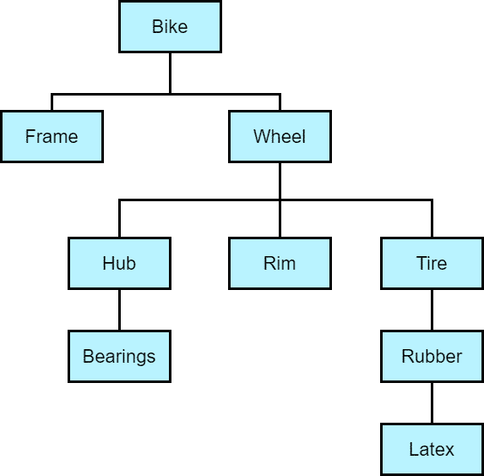

BOM structure diagram of assembly and component relationships for a bike.
BOM structure
This BOM structure diagram displays assembly and component relationships to build a bike.
Frames and wheels can be further assembled into different types of bikes.
Bike has QtyPer of 2 for Wheel.

Use Case 1: Component line overflow
MLS Objective: On-time availability
Business Use Case: Component line overflow
A factory has two component production lines that produce two different versions of an item. The factory is gradually shifting towards the new version, so making the new version is the default option. However, if the primary line is out of capacity, the additional demands should utilize the old version production line.
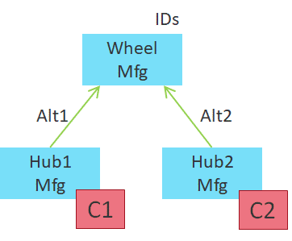
BOM structure
The assembly, Wheel, can be built using either a new version component (Hub1), or an older version component (Hub2).
Wheel has two PartSources with different BOMAlternate values:
Alt1 and Alt2 are alternate BOMs.
PartSource 1 uses Alt1, which explodes PlannedAllocation to Hub1.
PartSource 2 uses Alt2, which explodes PlannedAllocation to Hub2.
Hub1 is constrained by C1, and Hub2 is constrained by C2.
Where do you need MLS enabled?
Parts requiring MLS: All three parts
Reason: The decision branching point is Wheel. The supply availability information is on Hub1 and Hub2, since you are comparing on-time delivery capability of Hub1 and Hub2. The more on-time PartSource will be chosen automatically.
Wheel's PartSource.Priority can be used to indicate that Hub1 is the preferred path over Hub2 when both options can deliver on-time.

Use Case 2: Multiple parent assemblies
MLS Objective: On-time availability
Business Use Case: Multiple parent assemblies
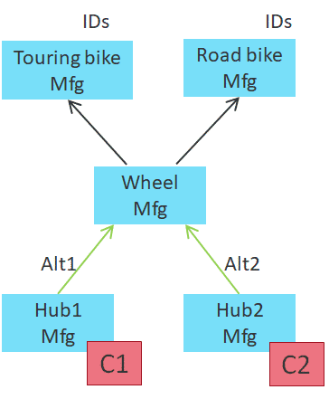
BOM structure
Continuing from the previous example, more parts are added above Wheel (assemblies that require Wheel to build). The rest of the setup is the same as before.
Where do you need MLS enabled?
Parts requiring MLS: Wheel, Hub1, and Hub2
Reason: The decision branching point is Wheel. The supply availability information is on Hub1 and Hub2, since on-time delivery capability of Hub1 and Hub2 are being compared.
The key thing to note here is that there is no benefit to turn on MLS for Touring bike and Road bike. Touring bike and Road bike do not have any decision to make, to be more specific:
- Touring bike/Road bike can only be built one way, which is using Wheel. There is no choice to make.
- Touring bike/Road bike doesn’t need to know the estimated availability of its demands, the Calculated PlannedOrder’s DueDate and Quantity won’t change either way.
Use Case 3: Partial planning
MLS Objective: On-time availability
Business Use Case: Partial planning

BOM structure
Continuing from the previous example, partial planning is added to all IDs on Touring bike and Road bike, with zero lateness tolerance.
The business use case is that if the driver demands cannot be satisfied on-time, the quantity should be reduced/shorted, and only supplies that can satisfy demands on-time should be created.
Where do you need MLS enabled?
Parts requiring MLS: All five parts
Reason: Different from the previous example, now the demands on Touring bike/Road bike need to know if it can be satisfied on-time, based on whether C1 or C2 has enough capacity.
The netting result (in this case CPO Quantity) on Touring bike/Road bike will depend on constraint availability on C1/C2.
Enabling MLS for all 5 parts allows each driver demand to dive into C1 and C2, and decide if it can be met on-time or not.
Common deployment examples
Use case introduction
The following use cases demonstrate common deployment examples and highlight the benefits of enabling MLS for certain parts in your product structure.
The following use cases provide examples and explanations on how MLS is enabled for some parts to achieve the best results for on time demands.
- Constraint load balancing relates to the capacity of different suppliers to be able to meet demand on time, or least late. Suppliers with available supply to meet on-time demand are chosen.
- Partial planning relates to demand expiry of a product. If the demands cannot be satisfied on time or within a defined lateness tolerance, the demand will be gone. This provides the ability to reduce / short driver demands if the factory cannot produce product on time or within a defined lateness tolerance.
- Synchronization among sibling components relates to ensuring that all components arrive close to the same time. Some components could be delivered earlier but would be sitting around in storage waiting for other components to be delivered.
- Non-blocking allocations relates to ensuring that sibling components are properly allocated to demands, so that some assembly demands are filled on time and no other assemblies are worse off than they would otherwise be.
Use case 1: Constraint load balancing
MLS Objective: On-time availability
Business Use Case: Constraint load balancing
CompanyA is a bicycle company that has many factories around the world. To make a bike, it needs to undergo over 20 manufacturing and testing procedures, and most of the pieces of equipment used have limited capacity.
Based on the capacity, a bike could be initially made in Taiwan, shipped to Malaysia for testing, and shipped to the US to a final consumer.
When possible, CompanyA prefers all production to happen in the same factory to reduce shipping costs, but maximizing production volumes and reducing order lateness are of higher priority.
This is a legitimate business problem that requires MLS to solve. When planning supplies to meet the driver demand, RapidResponse needs to know the constraint loading situation in each of the factories to decide which factory has a better chance at providing the supply on-time, or least late.
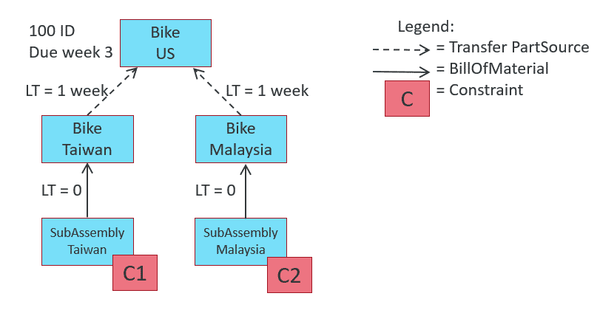
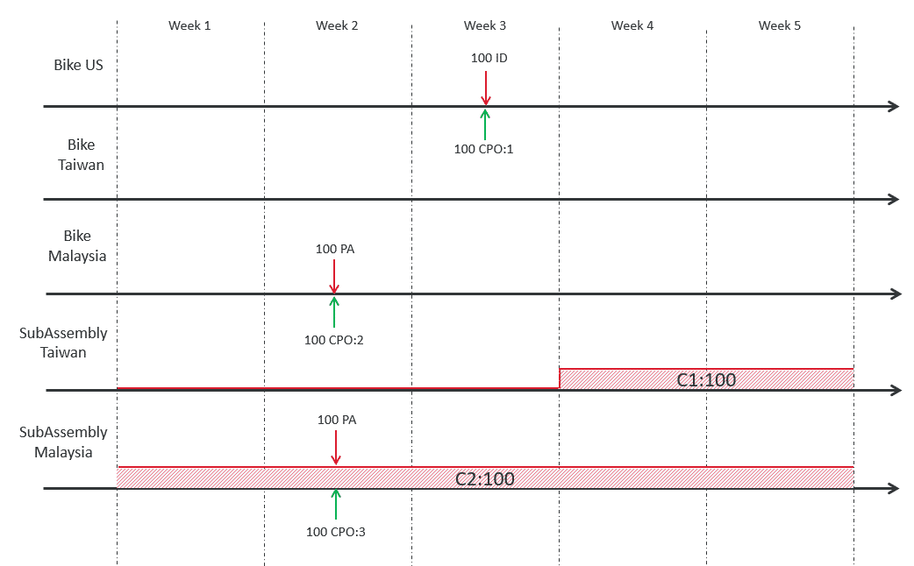

Where do you need MLS enabled?
MLS is enabled for all five parts
Which factory will be chosen to build supply, and why?
MLS chooses the Malaysia factory to build supply because constraint C2 has capacity in week 2 (lead time offset), and C1 has no capacity.
Building in C2 gives better on-time availability.

Use case 2: Partial planning in a complex product structure
(demand expiry)
MLS Objective: On-time availability
Business Use Case: Partial planning
CompanyB is a large racing bicycle manufacturer and its planning is primarily driven by forecast. This is a very competitive business sector and the retail customers have tons of options for similar racing bikes in competing brands.
CompanyB understands that if they cannot satisfy their forecast demands on-time, the demand will be gone. Excess inventory often gets sold at a discounted price because racing bike manufacturers push out a new model every year, and the old models don’t sell well after the new model is released.
CompanyB models their entire supply network in RapidResponse, and they want the ability to reduce / short driver demands if their factory cannot produce them on-time.
This is another use case that requires MLS. Driver demands need the visibility on lower level components and constraints to estimate whether they can be satisfied on-time or not. Based on that finding, RapidResponse will plan supplies differently on the driver level.
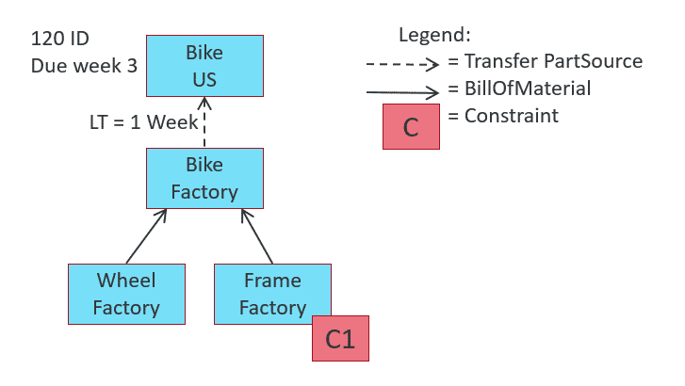
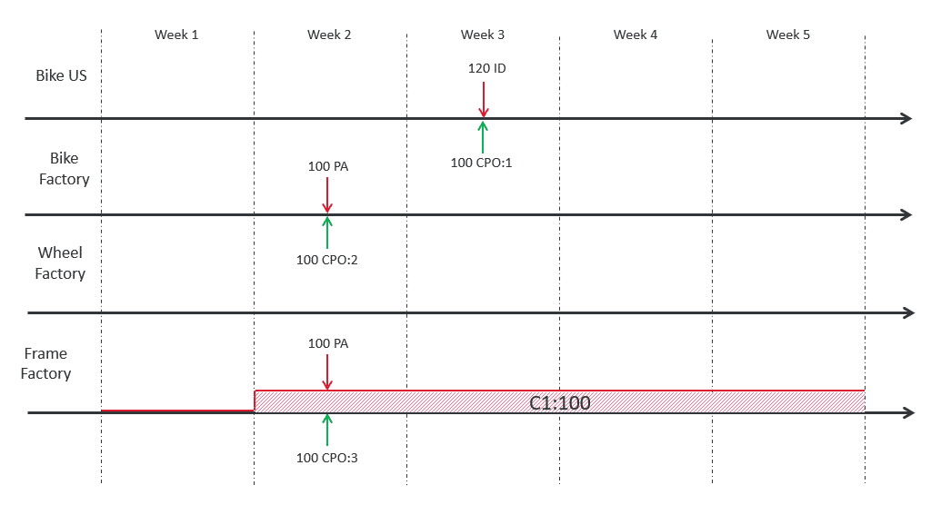
Where do you need MLS enabled?
MLS is enabled for three parts: Bike US, Bike Factory, Frame Factory.
Note: If there is a chance Wheel Factory can have material lateness, MLS should be enabled on Wheel Factory as well.
Where do you need partial planning enabled?
Partial planning is enabled on Bike US with zero lateness tolerance.
How much demand is satisfied, and why?
MLS sees that constrained constraint C1 can only supply 100 on time, so demand quantity is reduced by 20.
Use case 3: Synchronization among sibling components
MLS Objective: None - there is only one way to build, so no need to make any choices.
Business Use Case: Synchronization among sibling components
CompanyC makes adult tricycles and the final assembly takes up a lot of space. They have one component (frame) that is heavily constrained, but all the other components have unlimited availability.
CompanyC currently has the problem of the frame arriving late on the final assembly stage while all the other components are already available and taking up lots of space.
They want to plan their final assembly based on when frames can arrive.
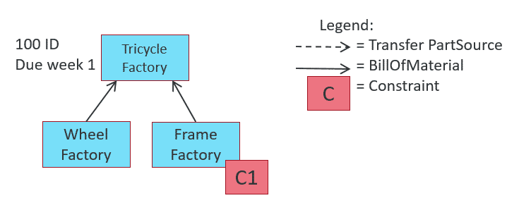
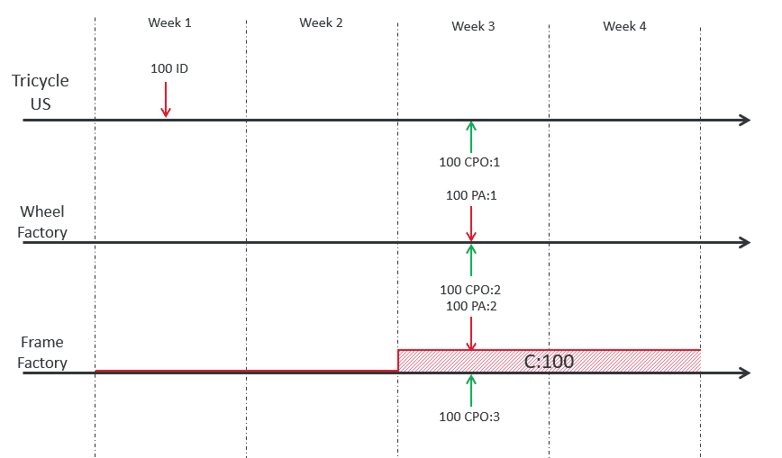
Where do you need MLS enabled?
MLS is enabled for two parts: Tricycle Factory and Frame Factory.
Note: If there is a chance Wheel Factory can have material lateness, MLS should be enabled on Wheel Factory as well.

How does RR ensure that all components arrive around the same time?
AllowLatePlan setting is enabled for Tricycle only.
MLS sees that the frame can only become available in Week 3 due to constrained constraint C1, so CPO:1 (on Frame)’s DueDate is delayed to Week 3, resulting in better synchronization for Frame Factory and Wheel Factory.
This is a use case that require MLS (and AllowLatePlan). Driver demands need the visibility on lower level components and constraints to estimate when it can be satisfied realistically.
Based on that finding, RapidResponse will delay the planning on the driver level so other components arrive around the same time as the gating component.

Use case 4: Non-blocking allocations
MLS Objective: On-time availability
Business Use Case: Non-blocking allocations
CompanyD produces bicycles and tricycles. There is a demand for assembly Bicycle, and Tricycle, and these assemblies share a common component: Wheel.
Wheel can satisfy only one of those assemblies on time.
AllowLatePlan is enabled for part ‘Tricycle’ only.
This is a legitimate business problem that requires MLS to solve. When planning supplies to meet the driver demand, RapidResponse needs to know the supply availability for all sibling components to decide which demand has a better chance at receiving the supply on-time, or least late.
Where do you need MLS enabled? What would happen if MLS is disabled?
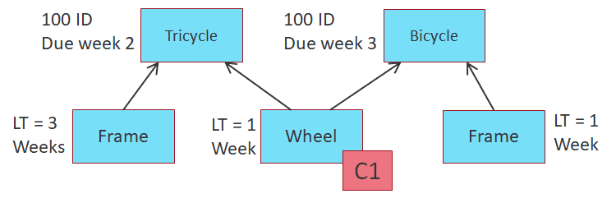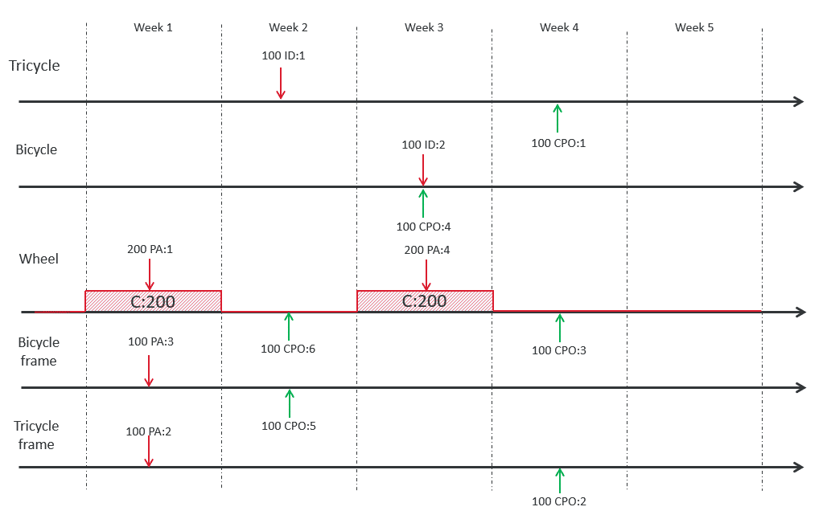

Where do you need MLS enabled?
MLS is enabled for four parts: Tricycle, Wheel and Tricycle frame. Bicycle frame should also have MLS enabled, although in this case it does not make a difference.
When allocating supplies to the demand for Tricycle, RapidResponse is able to identify its gating supply of component Tricycle frame. As a result it is allotted the later Week 4 supply of Wheel.
This frees up the earlier Week 1 supply of Wheel which is allotted to the demand for Bicycle.
This makes the demand for Bicycle now on time, without affecting the availability of the demand for Tricycle which is still determined by gating supply of component Tricycle frame.

What would happen if MLS is disabled?
If MLS is disabled on all parts, the on time supply of Wheel is used to satisfy the earlier demand from assembly Tricycle, and the late supply of Wheel is given to the later demand from assembly Bicycle.
However, despite receiving the on time supply of Wheel, note that the demand on Tricycle is late due to receiving late supply of its other component Tricycle frame. At the same time, the demand for Bicycle is also made late due to receiving the later supply of Wheel although its other component, Bicycle frame, provides supply on time.

Use case summary
1. When there are multiple sourcing options, each demand’s sourcing decision should have the best chance of meeting key MLS objectives such as on-time availability, part source priority, new purchase cost, existing supply cost, component supply level, component supply type, and so on.
2. When planning supplies to meet driver demand, RapidResponse needs to know the constraint loading situation in each of the factories to decide which factory has a better chance at providing the supply on-time, or least late.
3. Driver demands need the visibility on lower level components and constraints to estimate whether it can be satisfied on-time or not. Based on that finding, RapidResponse will plan supplies differently on the driver level.
4. For better synchronization among sibling components, AllowLatePlan should be enabled on a specific part that normally ships early and would sit around waiting for other parts to arrive. This way all the parts are synchronized and arrive around the same time.
5. When planning supplies to meet driver demand, RapidResponse needs to know the supply availability for all sibling components to decide which demand has a better chance at receiving the supply on-time, or least late.
Algorithm compatibility and limitations
Algorithms that should not be used together with MLS
There are some algorithms that should not be used together with MLS. The results of using these algorithms together with MLS may include decreased performance and incorrect planning leading to unexpected results.
The following algorithms should not be used together with MLS:
Dynamic safety stock
Orders for safety stock are created when a demand order causes projected inventory to fall below a predefined level. The determination of the safety stock level for each part is influenced by the applicable SafetyStockQuantityRule setting. Based on the setting in this field, safety stock can be set to a specified constant value (or series of time-phased constant values), or it can be dynamically calculated from demand using a number of different methods.
MLS has a limitation with all forms of dynamic safety stock. This includes Range of Coverage, FixedQuantity, TimePhasedSafetyDaysTotal, TimePhasedSafetyDaysMaximum, and FractionOfDemand.
The limitation is that the safety stock will only consider input demands, such as independent demands (IDs), allocations, and so on. The safety stock calculation will not consider any dependent demands.

Recommendations
Consider that when using MLS and dynamic safety stock together, only input demands such as IDs, allocations, and so on are considered, so it works as expected on any part that won’t receive dependent demands, such as driver parts (top level part of the current netting family).
If MLS and dynamic safety stock are used together on parts in the middle of a product structure, expect dynamic safety calculations to not include any dependent demands.
Tip: In many deployments where MLS is used, this simple 3-step process is used to simulate the effect of dynamic safety:
- Run scenario without MLS, with dynamic safety stock enabled
- Copy safety stock results to TimePhasedSafety table, and switch to TimePhasedSafety
- Run scenario with MLS
Dependent forecast consumption
MLS has a limitation with dependent forecast consumption, for very similar reasons compared to dynamic safety stock limitation.

Similar to dynamic safety stock, forecast consumption calculations in RapidResponse also happen in the initialization phase of Netting. With MLS enabled, parts are collected into the same family. When Dependent forecast consumption is attempted, dependent demands below the driver level (top level of the current Netting family) are not yet created, so consumption won’t happen.

Recommendations
Consider enabling MLS at the parts level that performs dependent forecast consumption instead of top level ordering parts. Dependent demands will be seen as external demands, and planning will work as expected.
Example: Dynamic safety stock
Objective: Maintain dynamic safety stock on the Bike @ Mfg level.
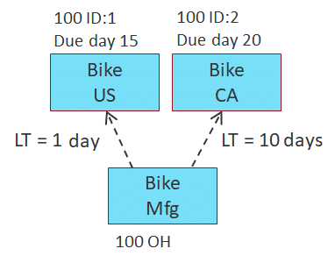
Non-MLS case
Some form of dynamic safety stock is enabled on Bike @ Mfg site. Without MLS, netting is first performed on US and CA sites and CPO:1 and CPO:2 created. Then, netting is performed for Bike @ Mfg site. The dynamic safety calculation happens during the netting initialization. Since parent CPOs are created already, when netting is initialized for Mfg site, PTA:1 and PTA:2 are collected in the list of demands. When the dynamic safety stock calculation is performed, the correct dependent demands are created.
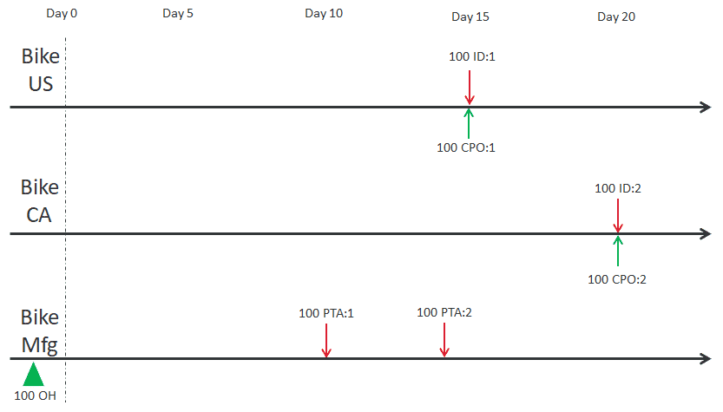
MLS case
Some form of dynamic safety stock is enabled on Bike @ Mfg site. With MLS enabled for all 3 parts, Bike @ US, CA, and Mfg are collected into the same netting family or calculation group, and netting happens on the 3 parts at the same time. When netting is initialized and dynamic safety calculation is performed for Mfg site, the result is nothing because dependent demands have not been created on Mfg site yet. This results in a safety stock level lower than what is expected.
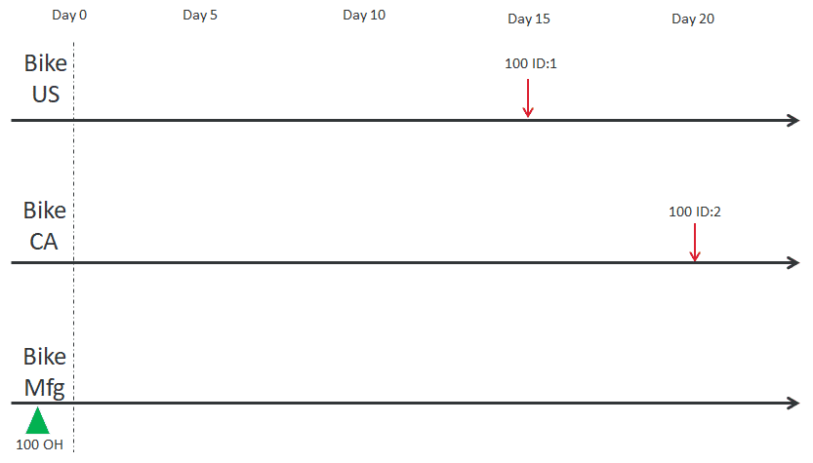
Example: MLS and Dependent forecast consumption
Objective: Bike has a lot of IDs, and Wheel has a lot of SalesForecasts. Perform dependent forecast consumption on Wheel.
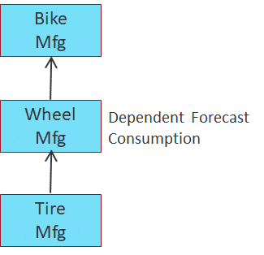
Analysis
If MLS is enabled for all 3 parts, dependent forecast consumption will not work because Wheel sees no dependent demands during netting initialization.
If MLS is enabled for Wheel and Tire only (and no MLS for Bike), dependent demands will be seen as external demands, and dependent forecast consumption will work as expected.
Note: Not enabling MLS on Bike could have other drawbacks, so this suggestion should be considered with caution.
Algorithms to be used with limitations together with MLS
There are some algorithms that can be used together with MLS but with some limitations. Using these algorithms together with MLS may include incorrect planning leading to unexpected results.
The following algorithms may be used together with MLS (with caution):
Lot sizing
MLS and large lot size
Lot size refers to PartSource.MinimumQty and MultipleQty. When lot size is enforced, RapidResponse could plan supplies with higher quantity instead of triggering demand.

When demands are processed in date sequence, excess generated by earlier demand can be used up by later-due demands. However, if later-due demands are processed first and generate huge excess, earlier-due demands will not use that supply because it is late. Instead, earlier-due demands will generate large supplies as well. This leads to short-term or long-term planning excess.
Recommendations
Setting MinimumQty and MultipleQty to 1 is recommended on parts where lot size does not matter.
This improves the robustness of MLS because all CPOs will be created as integers. Forecast demands without proper rounding can have 17 decimal places or more, and is not good input data.
Refrain from using large MinimumQty or MultipleQty if possible.
MaximumQty should be set to 0 (unlimited) when there is no MaximumQty that needs to be enforced. A small MaximumQty (relative to demand quantity) will cause significant runtime slow down as RapidResponse is forced to created more CPOs.
Attribute-based Planning
This section focuses on what can happen if MLS is used together with the attribute based planning (ABP) algorithm.
The unique characteristic about ABP is that CPOs created to satisfy demand with a certain DemandAttribute (FromAttribute in AttributeMap table) can only be used by demands with the same DemandAttribute. When there is no lot size, things work as expected because there is no excess.
When MLS and ABP and large lot size algorithms are used together, there's a possibility to end up with CPOs with a lot of excess tagged to a specific DemandAttribute, which makes it unusable for other demands with different attributes. Adding safety stock on top of this excess will make things worse.

Recommendations
ABP introduces additional checks to determine if a supply can be used for a demand. Default MLS just checks date and quantity, which is very fast.
When using MLS and ABP together, a check is also needed for attribute (if the driver demand has one) for every potential path in the product structure, on every level. This decreases the performance of MLS.
Therefore, design your ABP setup with the goal of attaching as few attributes to demands as possible. For example, use ABP for special path selection, and don’t put attributes on demands that can take any supply.

Stick to only using MLS and ABP algorithms without using large lot sizes or safety stock. If lot size/safety stock is absolutely needed, try to do it in a separate process, or enable it one piece at a time, and ensure planning results are still desirable and understandable.
Expiry planning
This section focuses on what can happen if MLS is used together with the expiry planning algorithm. Expiry planning is designed to process demands in date sequence in netting, regardless of PartType.CommitLevel setting.
Without MLS, demand processing by date sequence for all levels is guaranteed. With MLS active, demands are processed out of date sequence, which has the drawback of creating excess.
The main drawback of using MLS and expiry planning together is when safety stock is involved. Non-MLS and expiry planing logic (with ABP) has a special set of logic that refreshes the supply being held in safety stock, thus reducing expiry risks overall. This logic is disabled in MLS, because MLS breaks date sequence processing.

Recommendations
Currently using MLS and expiry planning together mainly focuses on getting the general MLS use case working with expiry planning (on time availability, multi-site load balancing, consuming existing supplies in product network).
With MLS enabled, for a work order without ExpiryDate given as input, the actual ExpiryDate is also calculated from its components and build process, instead of taking a guess using PartSource.IntervalsToExpiry. This can lead to better planning on parent levels.

Using MLS and expiry planning together will work as expected.
Using MLS and expiry planning and ABP together is also supported, but caution should be taken as ABP can cause some issues as previously described. Adding safety stock to this setup will cause many issues.
When using expiry planning and ABP and safety stock together, it is recommended to not use MLS, unless safety stock can be disabled in the scenarios that need MLS.
Days of supply
Days of supply logic is not supported with MLS. It is a design limitation of how days of supply logic currently works.
All forms of days of supply logic require the due date of the first CPO (or earliest due CPO). Without MLS, demands are processed in date sequence (within each OrderPriority, if used), so it’s easy to determine when to create the first CPO. Days of supply logic then happens on the fly for later demands.
As each demand is processed, and it's determined that a CPO should be created for it, the existing (earlier due) CPO is scanned to determine if its quantity just needs to be increased. The various days of supply settings determine when a new CPO is needed.
With MLS enabled, date sequence processing for demands is not guaranteed, so the first CPO created may not be the earliest due even for its own OrderPriority. This will cause wrong bucketing for all supplies of that OrderPriority.

Recommendations
Don’t use MLS together with days of supply.
If you want a consolidated view, use some authoring techniques to group multiple CPOs into one when displaying in a worksheet. For example you may round CPOs to a weekly calendar and display the sum of quantity.
CPO to SR conversion can also use a grouping approach. For example you may convert multiple CPOs into one SR. This could introduce some minor shifting sand issues, but it’s much better than determining days of supply for all CPOs in general.

Key Takeaways
Let's review the major topics you learned in this lesson:
Two key benefits of using MLS
- When there are multiple sourcing options, each demand’s sourcing decision should have the best chance of meeting key MLS objectives (on time availability, part source priority, new purchase cost, existing supply cost, component supply level, component supply type, and so on).
- Visibility into the product structure is required for RapidResponse to plan optimally on the driver level. For example setting DueDate for PlannedOrders.
MLS should not be used when:
- There are other algorithms used that are incompatible with MLS.
- There is only one way to build the product, and multi-sourcing does not exist.
- Multi-sourcing decisions are based on objectives that are vastly different than MLS objectives. For example if sources that provide on-time availability are not always preferred.
- There is little or no benefit in setting driver CPO’s DueDate based on availability information within the product structure (existing supplies, planning time fences, constraints).
Demand processing sequence
Demand processing sequence in regular netting is breadth-first, and in MLS is depth-first. MLS breaks the date-driven demand processing sequence, which can lead to worse planning results.
MLS and multi-sourcing / multi-level supply
MLS is useful when there are multi-sourcing situations, or multi-level supply visibility can help the driver level plan better (partial planning, component synchronization).
MLS does not fix everything
To have expected results with MLS enabled, you must first understand the results with MLS disabled.

Implement MLS with other algorithms
Incremental Availability
Incremental availability can be especially useful where late orders are concerned.
What does incremental availability do?

With incremental availability disabled, only the on-time quantity (the amount available by the due date) and the available date (the date the order is satisfied) are available.
With incremental availability enabled, it’s possible to see the different dates at which portions (or splits) of a given supply order could be ready between the due and available dates.
This involves considering the availability of an assembly’s components over time.
For example, some might be available now from on-hand inventory and others might be available from planned orders.
How does it work?
RapidResponse calculates incremental availability by first determining the date at which there is some supply available for all of an assembly’s components.
Then, the quantity of the assembly that can be built from the available supplies is recorded.
Finally, the available date for the split supply is calculated taking into account constraints (if applicable) and assembly lead time.
This process is then repeated until all supply splits for the assembly are recorded.
MLS parts and incremental availability
Parts that have MLS enabled should typically also have incremental availability enabled.
This ensures the benefits of MLS can be reflected on higher-level demands by allowing planned orders to be split and incremental available dates reported and rolled up to demands as portions of a late supply become available.
IncrementalRule
The IncrementalRule table is referenced by the Part table and holds values that can be used to turn incremental availability calculations on or off for each part. To turn incremental availability on, the parts IncrementalRule.ProcessingRule value should be set to “On”.
When incremental availability is on, supply orders for the part can be split if material becomes available over time, rather than all at once, or if constraint occurs in multiple periods. This value can be overridden on a supply-by-supply basis using the SupplyStatus.IncrementalSplit field.
When incremental availability is off, supply orders cannot be split with respect to material availability.
Note: The default value for IncrementalRule.ProcessingRule is "Off".
Incremental availability information is stored in the SupplyDemand table. The splitting of supplies results in additional records being added to this table. These records indicate the order(s) associated with the split, as well as details associated with each split.

Recommendations
- It is recommended that you do not generate incremental availability calculations for all parts because this increases the memory and execution time of the Capable-to-Promise (CTP) and Full-Level Pegging (FLP) algorithms.
- In general when using MLS, it is also recommended to turn on incremental availability for a part and its sub-parts. This ensures the complete flow of material availability throughout the product structure.
- Incremental availability calculations are turned on and off at the part level.
Note: While incremental availability can result in a plan that has better on time availability (or less lateness), the side-effect is a much higher cost in terms of additional setups for the items between the constrained or late item and the end item.
See the Data Model and Algorithm Help for best practices when using incremental availability.
MLS and AvailableRule
The AvailableRule table is used to control how available dates for a part’s supplies and demands are calculated.
By default, available dates are determined using all applicable capable-to-promise (CTP) rules. These rules can be ignored for parts that are considered unimportant in the calculation of availability (such as, vendor managed parts).
Parts that have MLS enabled should also have their applicable AvailableRule.ProcessingRule or Type.AvailableRule value set to “Normal”. With this setting, available dates are calculated using all applicable CTP rules and settings. Use of the “Normal” setting is required to ensure MLS is used in algorithm calculations for the part.
If AvailableRule.ProcessingRule is set to “Ignore” for a given part, then MLS will be automatically disabled for that part regardless of its MultiLevelSearchRule setting.
If AvailableRule.ProcessingRule is set to "FromType", available dates for supplies and demands of the part are calculated using the setting in PartType.AvailableRule (either “Ignore” or “Normal”).
Note: The default value for AvailableRule.ProcessingRule is "FromType".
Improved Time-phased parameter Usage (ITU)
Improved Time-phased parameter Usage is useful where planned orders are known to be late and where time-phased parameters such as yield improve over time.
When orders are late
Sometimes, because of constraints, planning fences, or other factors in dependent demand, Netting and MLS are unable to meet the due date for an independent demand.
This means the planned available date, or the MLS-calculated estimate of when a supply will be available is later than the original due date.
If some, but not all of the required dependent components can be made available by the due date, planned orders will be created that provide the required components earlier than they can be used.
Late orders and time-phased parameters
If time-phased parameters such as yield are used for a part, and the time-phased values improve over time, producing a dependent component too early can also mean waste, if a less-efficient yield factor is used to meet the demand.
How does ITU help?
ITU makes Netting and MLS more efficient when it is not possible to make a part available in time to meet the required due date.
If ITU is enabled, MLS will run additional trials to see what planning options are available if all dependent demand is due on the planned available date, instead of the original due date.
If part sources can be used that fully satisfy the demand under these conditions, then MLS updates the due date on the planned order, synchronizing PlannedOrder.DueDate with PlannedOrder.PlannedAvailableDate.
One side-effect of this synchronization is that dependent demand that would have been built too early (to meet the original due date) are aligned with other components so that everything is built only when it is needed to meet the planned available date.
Time-phased parameters and ITU
In industries where time-phased parameters improve over time, such as yield in semiconductor manufacturing, synchronizing the due date with the available date also allows Netting to take advantage of better yields, lead times, and other factors, if they improve after the original due date.
For example, if 100 units of a die are needed to meet demand for a computer chip, and the die manufacturing process has a 50% yield on the original due date, but has an 80% yield by the planned available date, ITU can use the 80% yield rate to place an order for 125 units, rather than the 200 that would be needed to account for the 50% yield rate.
How do you enable ITU?
ITU behavior is controlled by the MultiLevelSearchRule.SychronizationRule value. It has two possible values:
- PlanToDueDate: Due date is not synchronized with planned available date, and all time-phased parameters are read at the DueDate or ParameterDate of the planned order.
This is the default value.
- PlanToAvailableDate: If demand cannot be satisfied on time, MLS synchronizes the due date with the planned available date and runs additional trials. Time-phased parameters are read at the planned available date of the planned order, instead of at the DueDate or ParameterDate of the planned order.
Additional considerations
Note that ITU only synchronizes the due date to the planned available date within the Netting process.
- It is possible that CTP will calculate a new value for the actual available date of supply, which would be different from the planned available date.
i.e. DueDate = ParameterDate = PlannedAvailableDate ≠ AvailableDate
- ITU will still plan the most efficient orders possible, given the available information during the Netting phase.

Partial planning

Partial planning allows RapidResponse to ignore unsatisfied demand that cannot be satisfied within a time period.

Unsatisfied demand

A demand might be left unsatisfied because MLS determines one or more component supplies will be planned too late to allow the demand to be satisfied within a specified tolerance interval. For example, component supplies might be planned too late due to lead time or constrained part sources.

Unless availability of component supply is ensured throughout the product structure, MLS is generally recommended for use when enabling partial planning.

PlanningRule

The DemandType.PlanningRule field has a Full setting for demands that should always be satisfied and a Partial setting for demands that Netting logic should give up on and leave unsatisfied if they cannot be satisfied/planned within a given tolerance interval.

Logging unsatisfied demands from partial planning

As an option, if parts using MLS have demands configured for partial planning, then any demand portions left unsatisfied due to partial planning, along with details of the component supplies that led to those demands going unsatisfied can be reported in a series of tables.

Logging of unsatisfied demands is controlled through the MultiLevelSearchRule.LoggingRule field. With the default setting of Ignore, details of unsatisfied demands from partial planning are not logged. Logging data is useful, but may have a performance impact.

When LoggingRule is set to UnsatisfiedDemand, details of demands that were left unsatisfied due to partial planning and MLS, are logged in the following calculated tables:
- MLSActivity
- TrialCoByProductSupply
- TrialConstraintShortage
- TrialConsumption
- TrialPlannedOrder
- TrialSubstituteSupply

UnsatisfiedDemandLoggedQuantityRule

With details of unsatisfied demands being logged, the MultiLevelSearchRule.UnsatisfiedDemandLoggedQuantityRule further determines the portion of the unsatisfied demand and associated late supply portions that get logged. It has the following options:
- FirstLatePortion:
This is the default setting, and results in only the first late supply portion that caused MLS to leave the demand unsatisfied being reported (along with that corresponding portion of the unsatisfied demand). For example, if a given component supply is too late to satisfy the demand within tolerance, and constraint causes that supply to be available in multiple portions/days then only the first of those portions making the demand late beyond tolerance is reported (subsequent or later portions would not be reported).
- FullQuantityPrimaryPath:
The entire unsatisfied demand quantity is reported along with all supply portions that would be too late to satisfy it on time (or within lateness tolerance). Constraint consumption occurs as normal and, in cases when there is a lack of constraint available, demand logging might not continue all the way to lower levels in the structure. All supplies needed for the unsatisfied demand are assumed to be sourced from the primary part source determined by MLS.

FullQuantityPrimaryPathAfterNetting:
The unsatisfied demand quantity and supply portions late to satisfy it are reported after Netting completes and in the order that the demands were shorted. On-time input supply consumption is allowed, but only supplies left over from the usual netting process can be used. Constraint consumption is disabled during the downwards pass so constraint availability does not change where dependent demands get exploded. All supplies needed for the unsatisfied demand are assumed to be sourced from the primary part source determined by MLS.

Fairshare of material and constraints

Fairshare of material and constraints allows RapidResponse to distribute limited supply in a more equitable way.

Unsatisfied demand

Demands within a given priority level are typically processed in due date sequence. Earlier demands will typically be processed first and can be planned to use limited material and/or constraint throughout the product structure.

If MLS is used together with partial planning, earlier demands within a given tolerance interval can be planned first and use up potentially limited material and/or constraints, while later demands within the tolerance interval will be left disproportionately short when not all demands can be planned.

Other control settings to consider

The following other control settings should also be considered when implementing MLS.

1.PartType. AllocationQuantityRule

Parts that have MLS enabled are compatible with this setting which, when set to “Use”, includes demand size in the criteria for allocating a part’s limited component supplies (after due date, priority, etc.). However, when this option is set to “Use” for a single part that has MLS enabled, all other parts processed with that part are automatically treated as being set to “Use” as well.

For example, if this rule were set to “Use” for just a single component configured for non-blocking allocations under an assembly, then its related sibling components would inherit this rule as well.

Therefore, to disable this rule for a component that has MLS, ensure it is disabled on all other parts processed with that component.

Default value: Use

2.PartType. CommitLevel

For each part type, this setting controls how order commitments are maintained, and sets how priority is applied to netting (supply planning) and CTP (available date calculations).

If CommitLevel is set to "High", priority is used in both Netting and CTP. During Netting, priority is propagated from demands to supplies, and demands are processed in priority sequence. During CTP, priority is used when allocating supply to demand. This setting is appropriate for parts that have part sources with constraint and might have components with limited availability.

If CommitLevel is set to "MediumExplodePriority", priority is used in both CTP and Netting calculations. During Netting, priority is propagated from demands to supplies, however demands are processed in due date sequence instead of priority sequence. During CTP, priority is used when allocating supply to demand. Similar to “High”, this setting is appropriate for parts that have part sources with constraint and might have components with limited availability, but is intended for parts set to use lot sizing policies, configured as the primary product in a co-product/by-product structure, or as the primary component in a BOM level part substitution relationship.

A CommitLevel setting of "Medium" is appropriate for parts with only buy sources (with or without constraint) or make sources with no constraint. Priority is used in CTP, but not in netting. This means that priority is not propagated from demands to supplies, nor is priority used when allocating constraint to supplies for this part. However, priority is used when allocating supply to demand. For example, this setting would be used for purchased parts without supplier constraints.

A CommitLevel setting of "Low" is appropriate for parts where all part sources have no active constraint and where any make sources have unlimited availability. Priority is not used in either netting or CTP, nor is it used when allocating constraint. A low setting overrides a setting of Y on OrderPriority.MaintainCommitments.

Default value: Low

3.PartSourceType. ConstraintMultipleRule

This setting controls whether the lot size (as defined by PartSource.MultipleQty) is used when splitting supplies for constraint allocation or incremental availability of component materials. This setting is useful for parts that can only be built in defined batch quantities.

For parts that use MLS along with constraints and also have lot-sizing requirements, the ConstraintMultipleRule setting of "Use" should be used. This ensures that the multiple quantity is properly respected (it might not always be if ConstraintMultipleRule is set to "MultiplePeriods").

Additionally, the "Use" setting can help mitigate against the possibility of planned orders sometimes being created below the specified minimum quantity.

Default value: Use

4.ShipmentPolicy. PartialRule

For parts that have MLS enabled, this setting controls how non-blocking allocations are used under a given independent demand.

If an independent demand references the default ShipmentPolicy.PartialRule of “Partial”, which indicates the order is eligible for partial shipments, then component supply allocations are synchronized to the due date of the demand if possible. As a result, when a demand cannot be satisfied on time, earlier component supplies can potentially be released to satisfy other orders for whatever portion of the demand cannot be satisfied on time.

Otherwise, if the independent demand references a ShipmentPolicy.PartialRule of “Complete”, then component supply allocations are synchronized to the calculated available date for the demand. As a result, when a demand cannot be satisfied on time, all earlier component supplies can potentially be released to satisfy other orders. If an independent demand belongs to a ship set, this setting has no impact and is always treated as “Complete”.

Default value: Partial

5.ShipSetType. MultiLevelSearchRule

If MLS is enabled for parts with demands in a ship set, then this rule determines whether non-blocking allocations are considered across the demands in a ship set.

When a ship set has its Type.MultiLevelSearchRule set to “Use”, then component allocations under demands within the ship set are synchronized with those of the latest available demand in the ship set. This allows earlier supplies to be released and potentially used to improve availabilities on demands outside of the ship set.

If Type.MultiLevelSearchRule is set to “Ignore”, then non-blocking allocations are not considered at the ship set level.

Default value: Ignore

6.SupplyStatus. AllowLatePlan

This setting controls whether supplies can be planned later than their associated demand dates. When AllowLatePlan is set to "N" which is the default, then supplies are always planned to meet their demand date (although they might not always be available by that demand date).

For parts that use MLS and have AllowLatePlan set to "Y", the part's planned order due dates can be set to the date when the supply is realistically expected to be available based on any expected lateness of its components due to material availability and/or constraint. Thus if MLS determines a supply will not meet the demand date, its due date can be set later than the demand date (otherwise, the due date will still be planned to satisfy the demand date).

For parts that do not use MLS, the AllowLatePlan setting of "Y" only allows the late planning of a part's supplies when there is insufficient constraint available to it.

Default value: N

7.MultiLevelSearchRule. ShortTermExcess

Short-term excess inventory can result from the pre-building of supply due to order priority, dynamic safety stock, lot-sizing, and/or constrained planning. When using MLS, the MultiLevelSearchRule.ShortTermExcess setting can be used to limit the amount of excess supply held in the short term.

When ShortTermExcess is set to "Allow", short-term excess resulting from pre-building supply is allowed.

When ShortTermExcess is set to "Reduce", attempts are made to reduce short-term excess resulting from pre-building supply. MLS might pull-in or delay supplies to reduce near-term excess.

During the first pass, supplies are sorted by the date MLS expects them to be available, and demands are sorted by due date. Some potential impacts on planning results might occur. Dependent demand dates are updated as planned orders on higher levels are planned on different dates and with different start dates. Planned order dates change as supplies are balanced based on demands. Planned order priorities are raised based on the demand covered by the supply.

During the second pass, supplies are again sorted by the date MLS expects them to be available, and demands are sorted by request date. Some potential impacts on planning results might occur. Planned order request dates (used in two-date planning logic) are updated based on the demand being satisfied. If MLS determines the planned order will be late, the request date is then limited to the DemandDate of the planned order. Additionally with the "Reduce" setting, planned orders might sometimes be split to allow further reductions in excess supply. For example, this might occur if temporary excess supply occurs when pulling in planned orders to satisfy demand and the order being pulled in is more than needed.

When using the "Reduce" setting, the pulling in or delaying of planned orders cannot move them outside of their part source's effectivity. In cases of multiple part sources with short date effectivity ranges, the use of the "Reduce" setting can potentially introduce temporary excess supply and/or shortages.

Default value: Allow

Recommended default settings

It is important to enable MLS for the right set of parts. MLS is needed on all levels between the highest decision branching point down to the lowest supply availability gating factor. For better MLS performance, limit MLS usage, consolidate input demands, and prune unnecessary PartSources. Use the following recommended settings as defaults.

Incremental availability

RapidResponse provides control settings that turn incremental availability calculations on and off, and also influence the dates and quantities associated with the order splits resulting from incremental availability calculations. Incremental availability is turned on and off at the part level. This is done by setting the Part.IncrementalRule field for the part. Part.IncrementalRule references the IncrementalRule table which contains all incremental availability settings that have been defined.

Default value: Off

Recommendation: Part.IncrementalRule = "On" for all parts using MLS.

For more information on best practices for using incremental availability, see the Data Model and Algorithm Help.

Part source priority

This setting holds a priority value to use when selecting a PartSource from multiple active PartSources that can either provide the supply on-time or else equally late. Consuming excess supply is an MLS objective that uses up existing inventory first before planning new supplies. As a result, PartSource.Priority should not be used because this objective is too strong.

Default value: 0

Recommendation: Do not use PartSource.Priority values as a selection criteria. Set all PartSource.Priority field to be the same value.

Commit level

PartType.CommitLevel plays a major role in determining demand processing sequence in MLS, which subsequently determines which driver demand consumes early component supplies and constraints.

Default value: Low

Recommendation:
- If OrderPriority does not matter, use CommitLevel=Low
- If OrderPriority matters, use CommitLevel=High
- Do not use MediumExplodePriority as it introduces large amount of mismatch between netting and CTP.

Note: CommitLevel=High has a drawback where later-due high priority demands will steal early supplies and constraints. Reach out to the Kinaxis Professional Service team for a solution called Priority Striping to resolves this issue if this functionality is required.

Note: If expiry logic is used, demands are processed in date sequence regardless of CommitLevel.

Allow late plan

This setting controls whether a supply's due date is allowed to be set later than its associated demand date. Some higher level components require visibility to know if demands can be satisfied on time, otherwise due dates should be delayed based on estimated availability.

SupplyStatus.AllowLatePlan=Y should be treated with great caution, since a delayed DueDate cannot be rectified in CTP. When AllowLatePlan=Y is used for sibling component synchronization purposes, AllowLatePlan=Y should only be enabled on 1 level in the product structure, normally on the level above the sibling components being synchronized.

Default value: N

Recommendation: AllowLatePlan=Y should only be enabled on 1 level in the product structure.

Constraint scheduling

All parts sharing the same constrained constraint should use the same MLS rule. All parts should either have MLS=On or all have MLS=Off. This ensures better netting vs CTP alignment, because CTP relies on some MLS-specific fields when sorting supplies for constraint scheduling.

Recommendation: All parts that share the constraint should either have MLS=On or all have MLS=Off

Predefined resources supporting MLS

There are several predefined resources available to assist with enabling and/or measuring the impacts of MLS.

This includes the following:

1.MLS Configuration workbook

The MLS Configuration workbook can be used to identify parts that currently have MLS enabled or that might benefit from enabling MLS. This workbook allows you to view the configuration points for MLS functionality, which are discussed throughout this section. It also provides insight into potential data issues or settings that might adversely impact MLS calculations.

The following main worksheets are included in the MLS Configuration workbook:
- MLS Part Selection: Can report all parts that have MLS enabled. It can also be used to identify parts that don't currently use MLS but might benefit from using it. For example, parts that have many part sources or which have substitute parts might see better planning results when MLS is enabled. When this worksheet is selected, the MLS Rule worksheet is displayed in the lower workbook pane.
  - MLS Rule: Shows all records in the MultiLevelSearchRule control table and the settings on each. Parts can have their MultiLevelSearchRule setting changed using the MLS Part Selection worksheet.
- MLS Part Status: Can be used to identify parts with configuration issues that might adversely impact MLS results or performance. For example, instances are reported where a part uses certain control settings that are not compatible or recommended for use with MLS.
- MLS Configuration: Shows certain global configuration settings from the AnalyticsConfiguration table along with details on MLS trial operations.
- MLS Activity Log: Reports details about component supplies that expected to be late to satisfy a top-level demand (independent demand or forecast).
- Recursive Path: Can be used to identify recursive data structures where a part depends on itself (for example, if a part is found as a component within its own product structure). Recursive data structures should be avoided and fixed if found because they can cause RapidResponse algorithms to get into endless loops or produce incomplete results.

2.Control Tables workbook

The Control Tables workbook shows all records and settings in the MultiLevelSearchRule table for any given scenario. Additional worksheets in this workbook provide access to many other relevant configuration points and settings.

The following main worksheet that is relevant to MLS is included in the Control Tables workbook:
- MultiLevelSearchRule: Contains the controls that either set MLS on or off (referenced by Part), and contains other controls that tweak advanced or newer aspects of MLS. For example, including/excluding Cost function in MLS criteria.

3.MLS Performance Manager dashboard

The MLS Performance Manager dashboard allows comparison of solution quality between two selected scenarios. This can be useful in determining any potential benefits from enabling MLS on certain parts. For example, you can compare the number of late orders in each bucket between a scenario that doesn't use MLS and one that has it enabled on select parts.

The following main reports are included in the MLS Performance Manager dashboard. Each report presents summary information and allow drilling down for more detail on issues pertaining to a specific metric, priority level, or time bucket.
- Solution Quality Metrics Summary: Contains various demand fulfillment metrics that allow comparing the percentage of demands that are expected to on-time, late, and left unsatisfied between the two scenarios. A weighted metric based on how many days late the late demands are is also presented.
- Demand Status Transition Metrics: Shows demands whose availability status changed between the two scenarios. For example, you can identify demands that were late in one scenario but on time in another or demands that were late in one scenario but left unsatisfied in another.
- Demand Order Status by Due Date: Shows demands grouped into specified buckets and identifies the number on-time, late, or unsatisfied demands per scenario in each bucket.
- OnTime Demand by Priority: Compares number of on-time demands at each order priority level between the two scenarios.
- Late Demand by Priority: Compares number of late demands at each order priority level between the two scenarios.
- Unavailable Demand by Priority: Compares number of demands left unsatisfied at each order priority level between the two scenarios.
- Categorized Late Quantity: Reports supplies expected to be late to their demands in each of the scenarios, broken down into four configurable date buckets.

4.Part Properties workbook

The Part Properties workbook allows you to view and modify master data for all parts. You can view details including part lead times, sourcing information, costing data, single level bills of material, and where used information.

The following main worksheets are included in the Part Properties workbook:
- General: Provides basic Part information.
- Planning Policies: Allows enabling/disabling MLS on parts (reference to MultiLevelSearchRule), and also shows part planning information like RunDate, SS rules, and so on.
- Sourcing - General: Provides basic PartSource information, and lets you easily see which parts have multiple sources. A lot of these settings will influence standard part source logic. This worksheet also contains the MLSPreTargetSequence value, and you can see how BOMAlternates are getting used.
- Sourcing - Ordering: Shows lot-size, yields, and other policies.
- Sourcing - Lead Time Details: Shows various lead times on the part source, as well as PTF/PTFDate.
- Sourcing - Cost Details: Shows costing information on the part source.
- Components: Shows the BillOfMaterial records (assembly-component relationships) for your parts. It helps you understand how the BOMAlternates are being applied.

5.Planning Sheet workbook

The Planning Sheet workbook is the main source where master schedulers, planners, and buyers can analyze supply and demand information for one or more parts. You can also use it to show results for planning, availability, and forecast consumption or available-to-promise.

The following main worksheets are included in the Planning Sheet workbook:
- Supply & Demand: Based on CTPActivity table. Shows all demand/supplies for selected parts, along with running inventory balance. This can help you see where dependent supplies are placed/sourcing decisions are made, as well as showing lateness.
- Demand Orders: Based on IndependentDemand table. Shows end-item demands which MLS might ultimately help satisfy.
- On Hand: Based on OnHand table. Shows on hand inventory for certain parts.
- Supply Orders: Based on ScheduledReceipt table. Shows existing scheduled supply for certain parts.

Product Structure Analysis

Use case introduction

The most common mistake of MLS deployment is not having the right set of parts with MLS enabled.
If too many parts have MLS enabled, runtime performance is slower and results may be harder to understand.
If too few parts have MLS enabled, the solution solve quality may not be as good as it could be.

Keep the following points in mind when deciding what parts to enable MLS on.
- Before designing where MLS is required, you need to first identify:
  - All decision branching points
  - All supply availability points (availability gating factors)
- MLS is needed on all levels between the highest decision branching point down to the lowest supply availability gating factor.
- 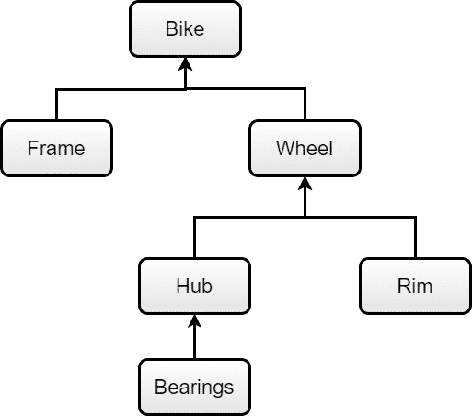

BOM structure

This BOM structure displays assembly and component relationships to build a bike.
Each bike contains a frame and a wheel component. Frames and wheels can be further assembled into different bike types.
Each wheel contains a hub and rim component.
Each hub contains a bearings component.

Use case 1: Component line overflow

MLS Objective: On-time availability
Business Use Case: Component line overflow

A factory has two component production lines that produce two different versions of an item. The factory is gradually shifting towards the new version, so making the new version is the default option. However, if the primary line is out of capacity, the additional demands should utilize the old version production line. The assembly, Wheel, can be built using either a new version component (Hub1), or an older version component (Hub2).

Wheel has two PartSources with different BOMAlternate values:
Mfg refers to part site.
Alt1 and Alt2 are alternate BOMs.
PartSource 1 uses Alt1, which explodes PlannedAllocation to Hub1.
PartSource 2 uses Alt2, which explodes PlannedAllocation to Hub2.
Hub1 is constrained by C1, and Hub2 is constrained by C2.



Where do you need MLS enabled?

Parts requiring MLS: All three parts

Reason: The decision branching point is Wheel.

The supply availability information is on Hub1 and Hub2, since you are comparing on-time delivery capability of Hub1 and Hub2.

The more on-time PartSource will be chosen automatically.

Wheel's PartSource.Priority can be used to indicate that Hub1 is the preferred path over Hub2 when both options can deliver on-time.

All previous ranked objectives would have to be equal for PartSource.Priority to be the deciding factor.

Use case 2: Multiple parent assemblies

MLS Objective: On-time availability
Business Use Case: Multiple parent assemblies

Continuing from the previous example, more parts are added above Wheel (assemblies that require Wheel to build). The rest of the setup is the same as before.



Where do you need MLS enabled?

Parts requiring MLS: Wheel, Hub1, and Hub2

Reason: The decision branching point is Wheel.

The supply availability information is on Hub1 and Hub2, since on-time delivery capability of Hub1 and Hub2 are being compared.

The key thing to note here is that there is no benefit to turn on MLS for Touring bike and Road bike. Touring bike and Road bike does not have any decision to make, to be more specific:
- Touring bike/Road bike can only be built one way, which is using Wheel. There is no choice to make.
- Touring bike/Road bike doesn’t need to know the estimated availability of its demands, the Calculated PlannedOrder’s DueDate and Quantity won’t change either way.

Use case 3: Partial planning
MLS Objective: On-time availability
Business Use Case: Partial planning
Continuing from the previous example, partial planning is added to all IDs on Touring bike and Road bike, with zero lateness tolerance. The business use case is that if the driver demands cannot be satisfied on-time, the quantity should be reduced/shorted, and only supplies that can satisfy demands on-time should be created.


Where do you need MLS enabled?
Parts requiring MLS: All five parts
Reason: Different from the previous example, now the demands on Touring bike and Road bike need to know if they can be satisfied on-time, based on whether C1 or C2 has enough capacity.
The netting result (in this case CPO Quantity) on Touring bike and Road bike will depend on constraint availability on C1 and C2.
Enabling MLS for all five parts allows each driver demand to dive into C1 and C2, and decide if it can be met on-time or not.
Use case 4: Sibling component synchronization (non-breaking allocation)
MLS Objective: On-time availability
Business Use Case: Sibling component synchronization (non-breaking allocation)
Continuing from Use case 2 (no partial planning enabled), two more component parts are added. Touring bike requires Frame1 + Wheel to build, and Road bike requires Frame2 + Wheel to build.
Because of constrained constraints C1 and C2, the factory understands that sometimes supplies for Wheel will be late. When building Touring bike, the factory wants to delay the date for sending Frame1 based on Wheel’s availability. This will improve supply synchronization between Frame1 and Wheel. Similar behavior for Wheel and Frame2 is desired.
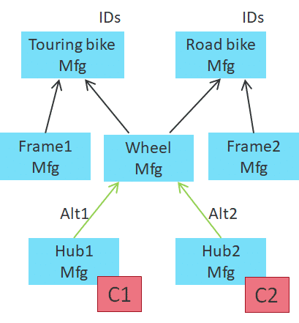
Where do you need MLS enabled?
Parts requiring MLS: Touring bike, Road bike, Wheel, Hub1, and Hub2
Reason: Different from Use case 2, now the demands on Touring bike/Road bike need to know if it can be satisfied on-time.
If not, Touring bike and Road bike’s CPO DueDate should be delayed based on the estimated availability.
AllowLatePlan must be enabled for Touring bike and Road bike (and AllowLatePlan disabled for all the other parts).
Enabling MLS starting from Touring bike/Road bike gives driver demands visibility into C1 and C2, so CPO DueDate can be delayed based on C1 and C2 availability.

Use case 5: Limited component availability
MLS Objective: On-time availability
Business Use Case: Limited component availability
Bike can be built either from Wheel1 or Wheel2. Wheel1 needs component Hub1, and similarly Wheel2 needs Hub2.
Hub1 and Hub2 are expensive materials, and there is a company-approved purchase plan for the next 12 months. Hub1 and Hub2 have many NonReschdulable SRs covering the 12 months period. This also means Hub1 and Hub2 cannot generate CPOs in the first 12 months.
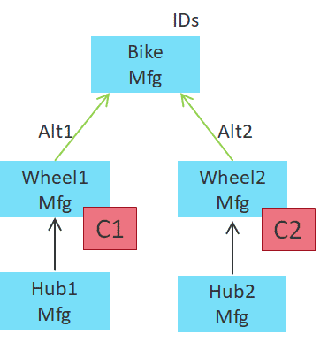
Where do you need MLS enabled?
Parts requiring MLS: All five parts
Reason: Decision branching point is on Bike, and supply availability information is from all 4 parts below Bike.
Wheel1/Wheel2 can have limited availability due to C1/C2, and Hub1/Hub2 can have limited material. This is a capacity constraint + material constraint situation.
Constraint C1 can only be utilized if there’s enough Hub1 supplies, and it’s the same for C2. Synchronization is needed between Wheel1 and Hub1, (same thing for Wheel2 and Hub2) so MLS should be enabled here.

Use case 6: Unlimited component availability
MLS Objective: On-time availability
Business Use Case: Unlimited component availability
Bike can be built using either Wheel1 or Wheel2. Wheel1 and Wheel2 are constrained by C1 and C2. Wheel1 needs component Hub1, and similarly Wheel2 needs Hub2. In this case, Hub1 and Hub2 are purchase parts with zero lead time, which means that they can create CPOs at any given time and the supply will be on time.

Where do you need MLS enabled?
Parts requiring MLS: Bike, Wheel1, Wheel2
Reason: Decision branching point is on Bike, and supply availability information is from Wheel1 and Wheel2 due to constraints.
Hub1 and Hub2 will not cause any lateness, so MLS is not needed for them.

Use case 7: More constrained levels
MLS Objective: On-time availability
Business Use Case: More constrained levels
Continuing from the previous example, one more product level is added, Bearings1 and Bearings2, which are constrained by C3 and C4 respectively.
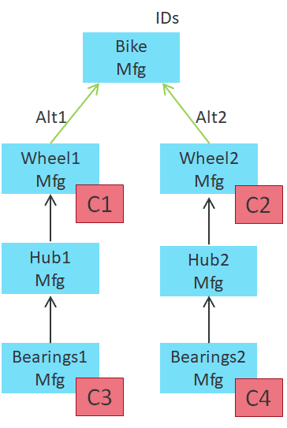
Where do you need MLS enabled?
Parts requiring MLS: All seven parts
Reason: Decision branching point is on Bike, and supply availability information at the deepest level is Bearings1 and Bearings2, due to constraints C3 and C4.
On each path, supply availability alignment is required between C1 and C3 vs C2 and C4 to determine the final availability in order to satisfy demands from Bike.

Use case 8: Demands on multiple levels
MLS Objective: On-time availability
Business Use Case: Demands on multiple levels
Mfg site can transfer parts to the Store site. However, both sites can get IDs, because sometimes parts are bought in bulk and ordered directly from Mfg site. Demands between Store and Mfg should compete for supplies in a fair manner.
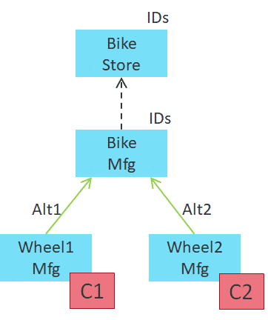
Where do you need MLS enabled?
Parts requiring MLS: All four parts
Reason: The main decision here is if MLS is needed for Bike at the Store site.

MLS is typically not required if there is no decision to make. Bike at Store site can only transfer from Mfg site, so there is no choice to make. However, MLS for Bike at Store site is still required for the following reason.

MLS leaves a special date (PlannedAvailableDate) and a special sequence (MLSSequence) on all CPOs (CalculatedPartialOrder) and PTAs (PlannedTransferAllocation).

Without MLS on Bike at Store site, the PTAs for Bike at Mfg site will have a disadvantage when competing for supplies against Mfg’s own IDs.

Use case 9: Demands from multiple sites
MLS Objective: On-time availability
Business Use Case: Component line overflow
Store and Outlet sites both source from the Mfg site. Mfg site does not have any IDs on it directly.
Bike can be built using either Wheel1 or Wheel2.
Wheel1 and Wheel2 are constrained by C1 and C2.
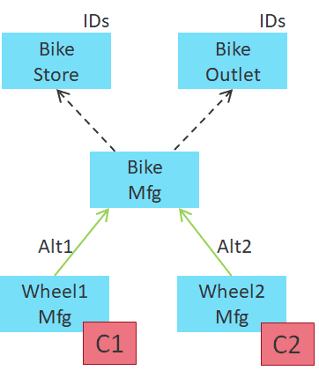
Where do you need MLS enabled?
Parts requiring MLS: Bike at “Mfg” site, Wheel1, Wheel2

Reason: This time there are no IDs on Bike directly, so the previous concern (from Use case 8) about IDs competing for supplies no longer exists.

IDs from Store and Outlet sites will both explode to become PTAs

ASI Using MLS: Milestone-based workflow
Milestone-based workflow
The nine step Milestone-based workflow consists of nine ordered steps that you should follow to ensure proper implementation of MLS.
It's important to follow these steps in order to achieve expected results with better run-time performance.
The nine steps to implement MLS are:
- Outline the business problem that requires MLS to solve
- Create a test case that represents the business problem, and verify outcome
- Define overall solution quality metrics as a baseline
- Perform MRP validation on the full data set without MLS
- Analyze the product structure and decide where MLS is required
- Enable MLS for one level, starting at the highest level (parts with smallest Part.LowLevelCode)
- Examine changes in solution quality metrics from Step 3
- Manually inspect the changes in your plan and look for anything strange
- Repeat from Step 6 and perform steps for the next level down, repeating this until all levels that require MLS are done
MLS makes planning results in RapidResponse more difficult to understand, as the planning result for the current part depends on information in the broader product network. The Milestone-based workflow is essential during an MLS deployment cycle to incrementally increase complexity and evaluate results at every checkpoint.

Step 1
Outline the business problem
Outline the business problem that requires MLS to solve, and identify the key MLS objective that should drive the decision making.

Reason:
You want to have a plan for your MLS deployment. You should have a clear idea of what configurations should be used ahead of time, and design the solution accordingly.
Step 2
Create a test case
Create a simple test case that represents your business problem, and verify the outcome.
Create a new scenario, use a few products in your product structure, implement MLS. Are the results what you expected?

Reason: You want to take your time and not rush through configuring MLS. Creating a simple test case right at the beginning of implementation will help highlight configuration issues early on.

You should try to get MLS working properly in your simple test case. This will give you a better chance to get it to work with real data.
Step 3
Define overall solution quality metrics as a baseline
Define overall solution quality metrics that measure the solution quality in RapidResponse.
Driver order fill rate and on time availability are good starting points.
Measure how many of your orders are filled and how many will be on time. These will be your baseline measurements to compare against.

Reason: MLS can change planning drastically. It is important to have a set of metrics that will show if the solve quality got better or worse after some configuration changes.
Digging into individual planning issues is only meaningful if the overall solution quality is good.
Step 4
Perform MRP validation
Perform Material Requirements Planning (MRP) validation on the full data set without MLS.

Reason: MLS makes all the other planning policies harder to follow.
Turning on MLS will highlight configuration issues in other areas.
It is key to ensure all the other analytic features are giving expected output results (PartSource setup, constraint setup, global substitution setup, and so on) before enabling MLS.
Once that’s done, use metrics from Step 3 to measure the solve quality, and use it as a baseline for future evaluations.
Step 5
Analyze product structure
Analyze the product structure and decide where MLS is required. Watch out for the risk of enabling MLS on too many parts.

Reason: Turning on MLS for more parts to see what happens is not the right strategy to deploy MLS.
Instead, you need to be able to identify all the places that should have MLS enabled based on your business problem, decision branching points, and supply availability (gating) points.
Make a record of this information without actually turning on MLS for these parts yet. Analyzing your product structure and knowing what parts to enable MLS for is crucial for achieving the best planning results with the best runtime performance.
Step 6
Enable MLS for one level
Starting from the highest level (parts with smallest Part.MultiSiteLowLevelCode), turn on MLS for one level.

Reason: MLS is a top-down, depth-first algorithm, so you should follow the logical sequence of enabling MLS top-down, one level at a time.
Step 7
Examine changes in solution quality metrics
Examine the solution quality metrics (from Step 3) and see how it changed.
If it stayed about the same or it improved, it’s a good sign. If the metrics got worse, you need to find the exact place and investigate.
For example, if you now see more late demands, you want to find out which demands they are.

Reason: This is where you need solution metrics that you created in Step 3.
The ability to quickly tell if the plan is getting better is key to a successful MLS deployment.
Step 8
Manually inspect changes
Manually inspect the changes in your plan for abnormal planning, and see if anything looks strange.

Reason: If there is a major change in planning as a result of enabling MLS for more parts, you should investigate why.
This is more important if the new results are worse than before.
Step 9
Repeat for next level
After making sure the planning changes are desirable, go back to Step 6 and enable MLS for the next level down. Repeat these steps until all levels that require MLS are done.

Reason: The most challenging part of an MLS deployment is trying to understand why MLS picked a certain path.
Limiting the amount of data change in each iteration, helps identify more quickly which data change led to the change in overall results.

This process might seem time consuming, but experience from past deployments shows that you will arrive at a robust MLS solution implementation much faster this way, with less chances of running into issues and getting stuck.

MLS PERFORMANCE
Performance and solution improvements
Recent changes to the underlying Automated Sourcing Intelligence (ASI) architecture help improve stability, maintainability and performance of MLS in RapidResponse. These changes also increase the solution quality by fine-tuning complex feature interactions and interactions with other algorithms.
In some cases, improvements of three times reduction in computational time, and three times reduction in memory requirement were recorded.
Some improvements to the MLS algorithm include:
1.Improved source path selection
Better constraint and material utilization, leading to more accurate path/source selections.
2.Improved scheduled receipt
Dependent demands do not have to be satisfied by a single order, leading to reduced inventory and improved constraint consumption.
3.Larger quantities being rolled up during calculations
Multiple OnHand and excess supply orders are rolled up in a single pass, leading to increased performance by satisfying orders with less work.
4.Source selection criteria changes
MLS Performance Manager dashboard
The MLS Performance Manager dashboard allows you to compare metrics for two scenarios to determine which one provides better solution results.
The dashboard displays a comparison of metrics like late demand, on time demand, unavailable demand, quantity weighted days late, and demand priority details.
This visual comparison of two scenarios allows you to make faster more accurate decisions in choosing the better solution for your planning needs.
Performance evaluation
Some key points to keep in mind when evaluating the performance of your MLS algorithm implementation:
- Planning with MLS enabled will always take longer compared to non-MLS. MLS needs to perform more calculations, so naturally this process will take longer than if MLS was disabled. The more parts you have in your product structure with MLS enabled, the longer MLS will take to return results.
- Enabling MLS will highlight configuration issues that impact performance. Since scenarios where MLS is disabled have fast runtimes, configuration issues that slow down performance are often hidden. Following the Milestone-based wokflow and the suggestions in the list of recommended default settings will improve performance and solution quality.
In general, MLS performance is affected by:
- Size of the largest netting family. It is good practice to enable MLS for just enough parts to solve your business problem, and no more.
- Total number of driver demands. It is good practice to reduce the total number of input demands into RapidResponse. This could mean doing forecast spreading using a weekly calendar instead of a daily calendar, or consolidating multiple demands into one demand.
- Number of MLS-enabled parts that each driver demand needs to evaluate. It is good practice to reduce the number of choices at each decision branching point. You can clean up duplicate part sources and disable unused part sources.
Recommended default settings
It is important to enable MLS for the right set of parts. MLS is needed on all levels between the highest decision branching point down to the lowest supply availability gating factor.
For better MLS performance, limit MLS usage, consolidate input demands, and prune unnecessary PartSources. Use the following recommended settings as defaults.
1.Incremental availability
RapidResponse provides control settings that turn incremental availability calculations on and off, and also influence the dates and quantities associated with the order splits resulting from incremental availability calculations. Incremental availability is turned on and off at the part level. This is done by setting the Part.IncrementalRule field for the part. Part.IncrementalRule references the value of IncrementalRule.ProcessingRule.
Default value: Off
Recommendation: IncrementalRule.ProcessingRule = "On"
For more information on best practices for using incremental availability, see the Algorithm and Data Model Help.
2.Part source priority
This setting holds a priority value to use when selecting a PartSource from multiple active PartSources that can either provide the supply on-time or else equally late.
Consuming excess supply is an MLS objective that uses up existing inventory first before planning new supplies.

As a result, PartSource.Priority should not be used because this objective is too strong.
Default value: 0
Recommendation: Do not use PartSource.Priority values as a selection criteria to determine between part sources. Set all PartSource.Priority field to be the same value.
3.Commit level
PartType.CommitLevel plays a major role in determining demand processing sequence in MLS, which subsequently determines which driver demand consumes early component supplies and constraints.

Default value: Low
Recommendation:
- If OrderPriority does not matter, use CommitLevel=Low
- If OrderPriority matters, use CommitLevel=High
- Do not use MediumExplodePriority as it introduces large amount of mismatch between Netting and CTP.
Note: CommitLevel=High has a drawback where later-due high priority demands will steal early supplies and constraints. Reach out to the Kinaxis Professional Service team for a solution called Priority Striping to resolves this issue if this functionality is required.
Note: If expiry logic is used, demands are processed in date sequence regardless of CommitLevel.

4.Allow late plan
This setting controls whether a supply's due date is allowed to be set later than its associated demand date. Some higher level components require visibility to know if demands can be satisfied on time, otherwise due dates should be delayed based on estimated availability.

SupplyStatus.AllowLatePlan=Y should be treated with great caution, since a delayed DueDate cannot be rectified in CTP.
When AllowLatePlan=Y is used for sibling component synchronization purposes, AllowLatePlan=Y should only be enabled on 1 level in the product structure, normally on the level above the sibling components being synchronized.
Default value: N
Recommendation: AllowLatePlan=Y should only be enabled on 1 level in the product structure.
5.Constraint scheduling
All parts sharing the same constrained constraint should use the same MLS rule. All parts should either have MLS=ON or all have MLS=Off.
This ensures better netting vs CTP alignment, because CTP relies on some MLS-specific fields when sorting supplies for constraint scheduling.
Recommendation: All parts should either have MLS=ON or all have MLS=Off
Takeaway concepts and best practices
Below is a list of take away concepts and suggestions for implementing MLS.
- Enable MLS for the right set of parts. MLS is needed on all levels between the highest decision branching point down to the lowest supply availability gating ssfactor.
- Follow the Milestone-based workflow to define metrics and create test cases early on. Once full data is ready, incrementally turn on MLS and evaluate results against your baseline metrics.
- For better MLS performance, limit MLS usage, consolidate input demands, and remove unnecessary PartSources.
- Use the recommended default settings as the default setup for your environment.
Two key benefits of using MLS are:
- When there are multiple sourcing options, each demand’s sourcing decision should have the best chance of meeting key MLS objectives (on time availability, part source priority, new purchase cost, existing supply cost, component supply level, component supply type, and so on).
- Visibility into the product structure is required for RapidResponse to plan optimally on the driver level. For example setting DueDate for PlannedOrders.
MLS should not be used when:
- There are other algorithms used that are incompatible with MLS.
- There is only one way to build the product, and multi-sourcing does not exist.
- Multi-sourcing decisions are based on objectives that are vastly different than MLS objectives. For example if sources that provide on-time availability are not always preferred.
- There is little or no benefit in setting driver CPO’s DueDate based on availability information within the product structure (existing supplies, planning time fences, constraints).
Demand processing sequence in regular netting is breadth-first, and in MLS is depth-first. MLS breaks the date-driven demand processing sequence, which can lead to worse planning results.
MLS is useful when there are multi-sourcing situations, or multi-level supply visibility can help the driver level plan better (partial planning, component synchronization).
MLS does not fix everything. To have expected results with MLS enabled, you must first understand the results with MLS disabled.

